Creating a Custom Filter:
By filtering information in a worksheet, you can find values quickly. You can filter on one or more columns of data. With filtering, you can control not only what you want to see, but what you want to exclude. You can filter based on choices you make from a list, or you can create specific filters to focus on exactly the data that you want to see.
You can search for text and numbers when you filter by using the Search box in the filter interface.
When you filter data, entire rows are hidden if values in one or more columns don't meet the filtering criteria. You can filter on numeric or text values, or filter by color for cells that have color formatting applied to their background or text.
How?
Select the data that you want to filter
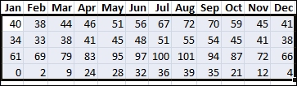
- On the Data tab, in the Sort & Filter group, click Filter.
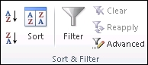
- Click the arrow in the column header to display a list in which you can make filter choices.
Note Depending on the type of data in the column, Microsoft Excel displays either Number Filters or Text Filters in the list.
Filter by selecting values or searching
Selecting values from a list and searching are the quickest ways to filter. When you click the arrow in a column that has filtering enabled, all values in that column appear in a list.
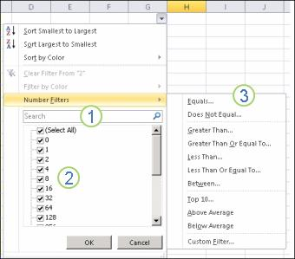
1. Use the Search box to enter text or numbers on which to search
2. Select and clear the check boxes to show values that are found in the column of data
3. Use advanced criteria to find values that meet specific conditions
- To select by values, in the list, clear the (Select All) check box. This removes the check marks from all the check boxes. Then, select only the values you want to see, and click OK to see the results.
- To search on text in the column, enter text or numbers in the Search box. Optionally, you can use wildcard characters, such as the asterisk (*) or the question mark (?). Press ENTER to see the results.

Filter data by specifying conditions
By specifying conditions, you can create custom filters that narrow down the data in the exact way that you want. You do this by building a filter. If you've ever queried data in a database, this will look familiar to you.
- Point to either Number Filters or Text Filters in the list. A menu appears that allows you to filter on various conditions.
- Choose a condition and then select or enter criteria. Click the And button to combine criteria (that is, two or more criteria that must both be met), and the Or button to require only one of multiple conditions to be met.
- Click OK to apply the filter and get the results you expect.

Next steps
- Experiment with filters on text and numeric data by trying the many built-in test conditions, such as Equals, Does Not Equal, Contains, Greater Than, and Less Than. For more information, see Filter data in a range or table.
Note Some of these conditions apply only to text, and others apply only to numbers.
- Create a custom filter that uses multiple criteria. For more information, see Filter by using advanced criteria.
- Learn how to Filter for unique values or remove duplicate values.

Advanced Filter in Excel:
Advanced Filter in Excel is the next level filter option available in the Data menu tab under Sort & Filter section, which filters the selected data per the criteria we set for this. For this, first, we need to scrub the data by removing the blank cell and keeping the header in all the columns. To advance filter, we need to define the criteria by which we need to filter the data, and the criteria should be placed in separate cells from the table. Once we select the Advanced Filter Option, select the complete range we want to filter, then select the cell where we defined the criteria.

How to Use Advanced Filter in Excel?
This Advanced Filter is very simple easy to use. Let us now see how to use the Advanced Filter in Excel with the help of some examples.
Advanced Filter in Excel Example #1
Suppose you have the following dataset and have to get all the records where the order total is greater than 900, and the employee name is “Nishu Kumari”.
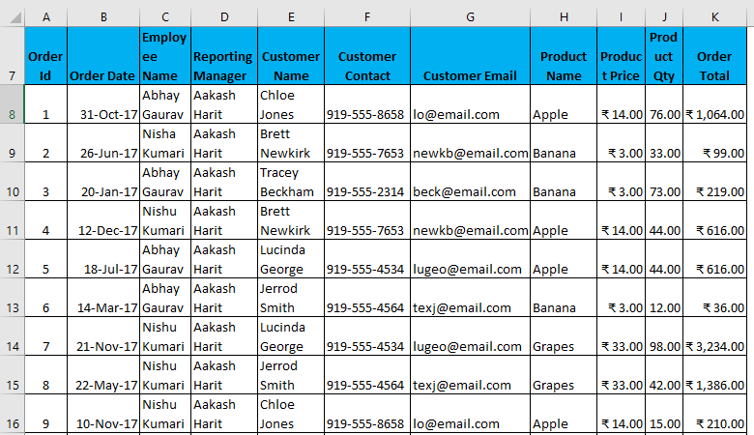
- To use an advanced filter with some criteria, first, you must copy all the headers & paste them somewhere else in the worksheet. (In my case, I will use blank rows to make it easier to understand.
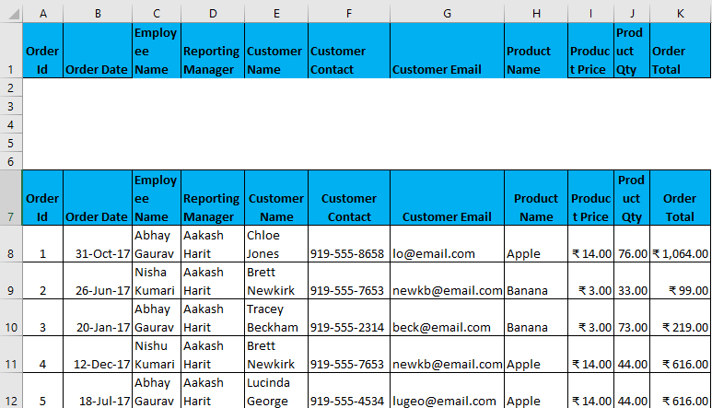
- Now, specify the conditions under these headers according to your requirement, which will act as an input in a filter.
- Now, select the entire data set, headers, and Go-To Data tab – Sort & Filter. This will open the Advanced Filter dialog box.
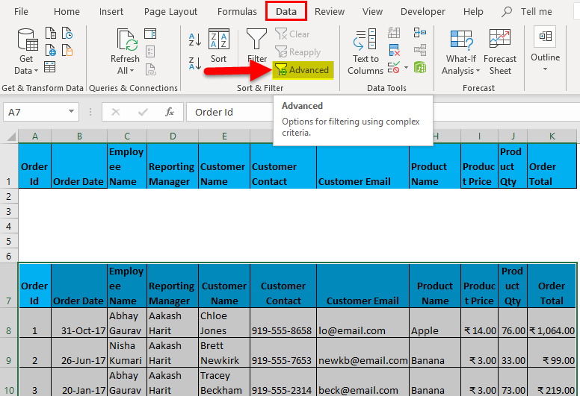
- Hotkey to applying the advanced filter after selecting the dataset is (Alt key+ A+ Q).
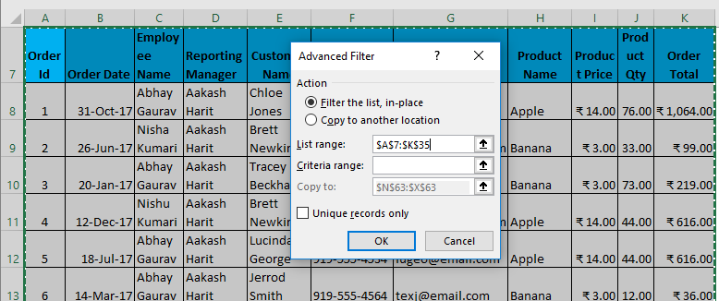
  - Now, as shown above, you have to enter the following details:
- Action: It has 2 options. First, filter the list in place (this will remove the original data, and the result of this filter will place in the same location), and Second, copy another location. (this will allow you to save filtered data on location)
- List Range refers to the dataset from where you want to find data. (Here it’s A7: K35)
- Criteria Range: In this, Criteria are mentioned (A1: K2)
- Copy To: This cell will be activated using the second option in the Action criteria.
- Copy Unique Records Only: Check this only if you require unique records.
- I have entered all the details in this dialogue box and chose to copy them to another location(A38) with unique records.
- It will look as in the Screenshot on the next page. Now click ok, and it will give all unique records.
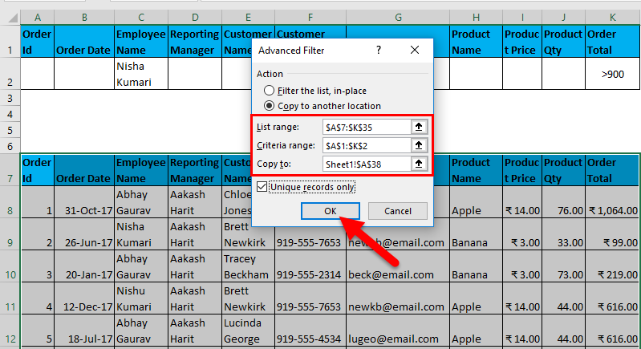
The output is given below, showing only those data containing the Employee name Nishu Kumari.
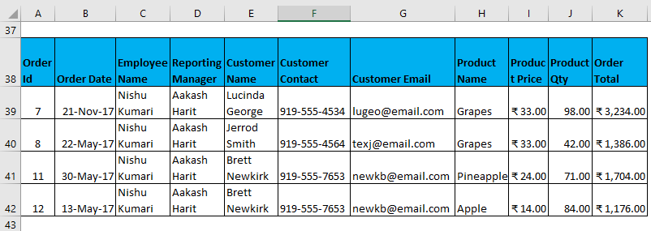

Error Proofing
Proofing is used in Excel to check the spelling, research, thesaurus, and translation in Excel. Data proofing settings can be accessed through clicking on File->Options->Proofing in MS-Excel.
Here are ten easy steps to diagnose, repair and future-proof your spreadsheet templates and financial models and become a Microsoft Excel expert in your (home) office.
1. Find and correct all #-errors
Look for #DIV/0, #N/A, #NAME?, #NULL!, #NUM!, #REF!, #VALUE!.
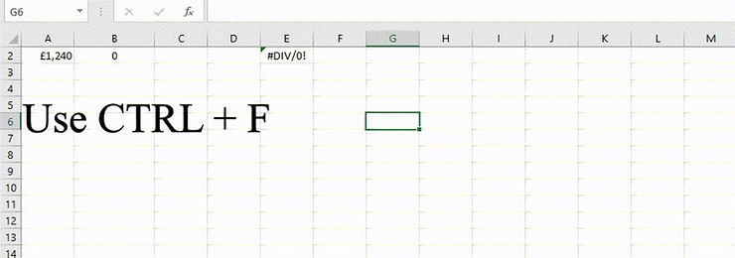

2. Revise lookup range references
Expand reference ranges to full columns if needed.
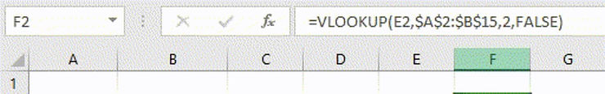

3. Check and adjust units
EUR or GBP? 1’000s or units? It might not always be so obvious.
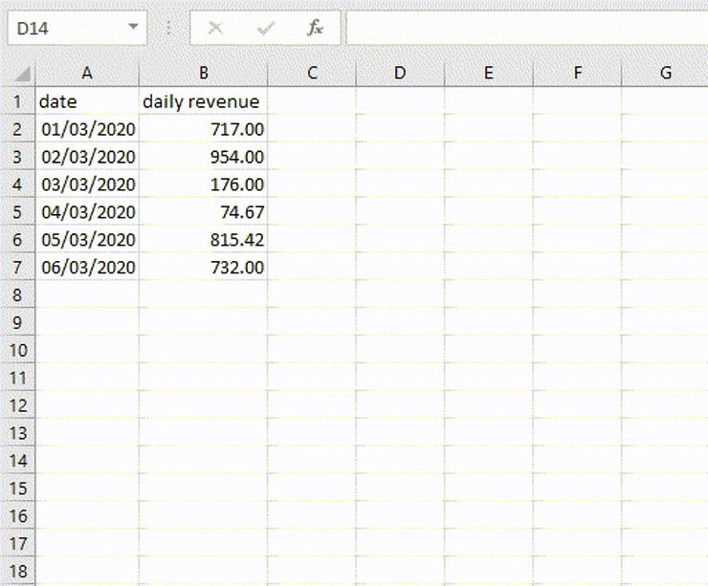

4. Document procedures and write manuals
Act as you saw the file for the first time. At a minimum, write: who, when & how. And be accurate. Cell C217 of the “2019 Q1 quotations” worksheet is better than “That 10k-ish payment from that coding company”.
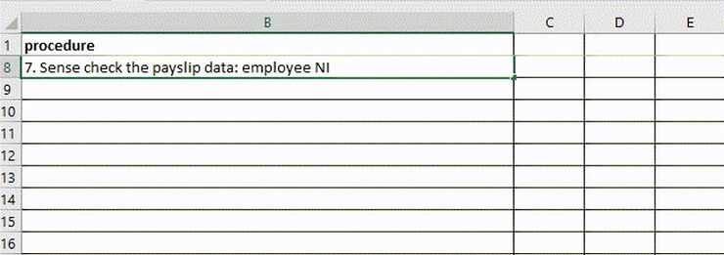
5. Remove or hide tabs you don’t need to reveal

No ambiguous notes or complex formulas for non-technical end-users allowed!
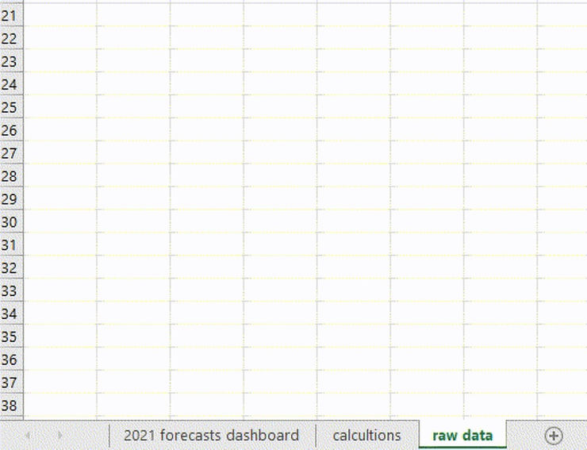

6. Organise folders with periodical reports
Remove partial versions, corrupted files and unnecessary copies to help other Excel users.


7. Introduce version control
Add a list of versions, updates and changes. That’s crucial for remote, collaborative work.
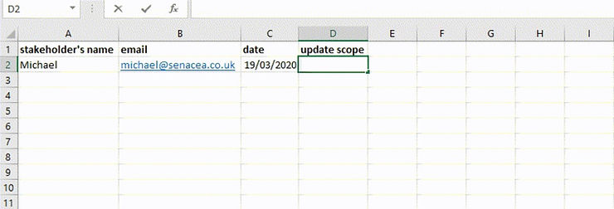

8. Create a list of all your periodical Excel reports for months ahead.
Every Excel specialist plans their work early on.
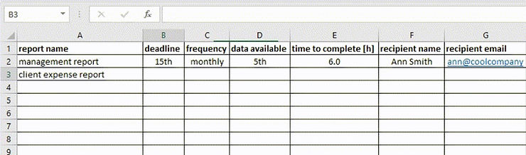

9. Learn VBA, at least the easy stuff.
It’s one of the most accessible programming languages and lets you automate spreadsheets with macros. Most finance or reporting departments need VBA developers or Excel macro programmers at some point.

Conditional Formatting in Excel enables you to the cells with certain color depending on the condition. It is an excellent way to visualize data in a spreadsheet. You can also create rules with your own custom formulas. This guide will provide you with step-by-step examples of the most popular conditional formatting functions.
What is Conditional Formatting?
Conditional formatting is a feature in Microsoft Excel that allows you to apply specific formatting to your cells according to certain criteria. It enables you to make sense of your data and spot significant trends.
Highlight Cells Using Conditional Formatting
Let’s start by highlighting the cells that have a value greater than 350. Execute the following steps:
- Select the range of cells you want to apply the highlight.
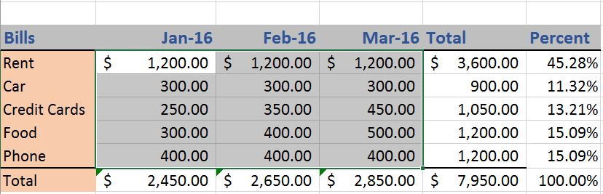
- On the Home tab, under Styles Group, click Conditional Formatting.
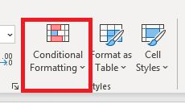
- Click Highlight Cells Rules > Greater Than
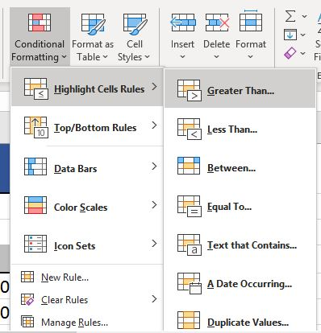
- Enter the desired value and select the formatting style.
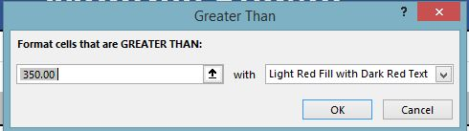
- Click OK

Result:
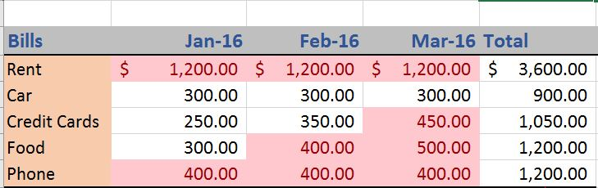

Clear Formatting
To clear the formatting rules, follow these steps:
- Select the range of cells where conditional formatting is applied.
- Go to Home tab > Styles Group > Conditional Formatting
- Click Clear Rules > Clear Rules from Selected Cells
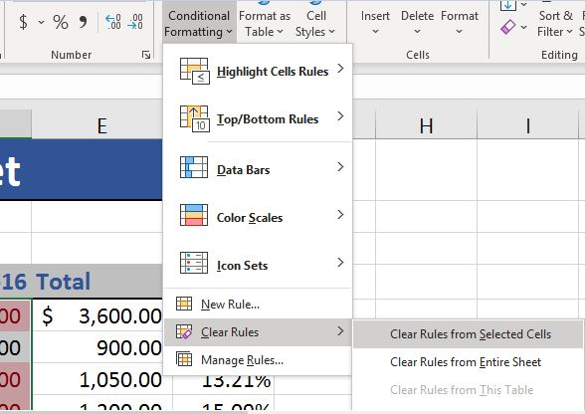

Conditional Formatting With Formulas
Formulas that apply conditional formatting must evaluate in true or false.
- Select the range of cells where you want to apply conditional formatting.
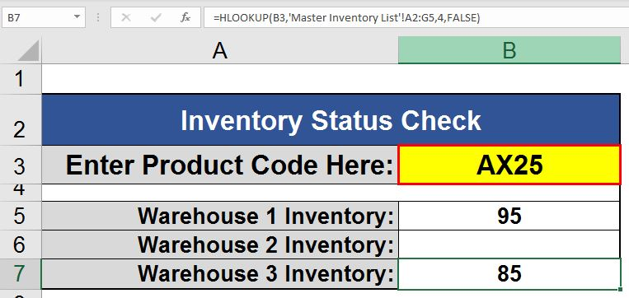
- On the Home tab, under Styles Group, click Conditional Formatting.
- Click New Rule.
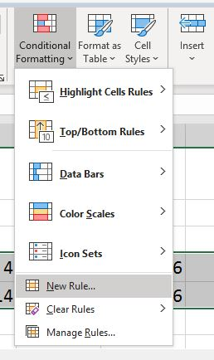
- Select ‘Use a formula to determine which cells to format‘.
- Enter the formula.
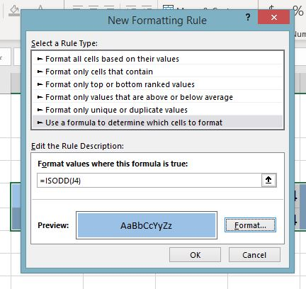
- Select a formatting style and click OK.

Result:
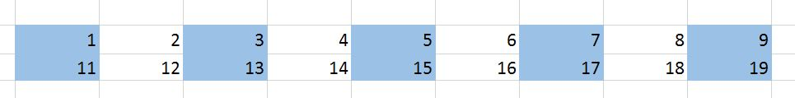

Highlight Bottom Items
Conditional Formatting can also be used to fetch the top and bottom items in your sheet. Suppose you want to get the five lowest pay rates among the given pay rates. Execute the following steps to do that:
- Select the range of cells where you want to apply conditional formatting.
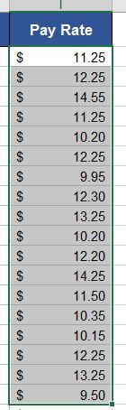
- On the Home tab, under Styles Group, click Conditional Formatting.
- Click Top/Bottom rules > Bottom 10 Items
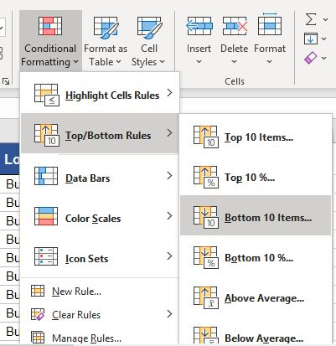
- Mention the number of lowest records you want to highlight.
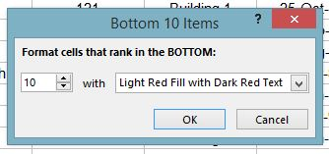
- Click OK.
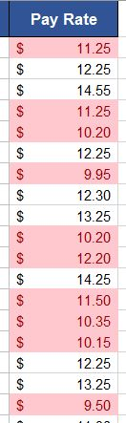

Find Duplicate Values in Range of Cells
You can highlight the duplicate values in a range of cells using conditional formatting. To implement that, follow these steps:
- Select the range of cells.
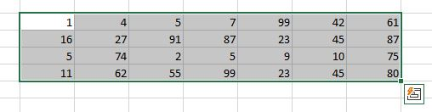
- On the Home tab, go to Styles Group > Conditional Formatting.
- Select Highlight Cells Rules > Duplicate values.
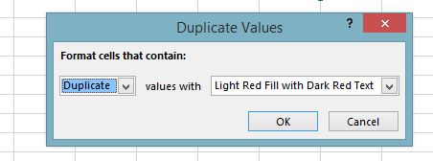

Result:
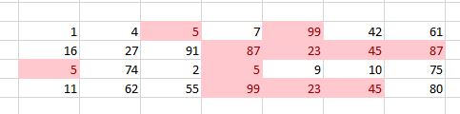

Data Bars in Conditional Formatting
Data bars in Excel are used to visualize the range of cells. The longer bar represents a higher value. To add the data bars, follow these steps:
- Select the range of cells.
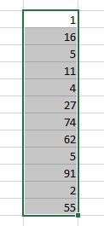
- On the Home tab, go to Conditional Formatting > Data Bars and select a subtype.
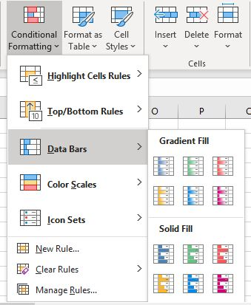

Result:
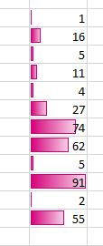
Data validation is a feature in Excel which is used to control what users can enter into a cell. It allows you to dictate specific rules. It also allows users to display a custom message if users try to enter invalid data.
What Is Data Validation in Excel?
Data validation in Excel is a technique that restricts user input in a worksheet. It is often used to limit user entry.
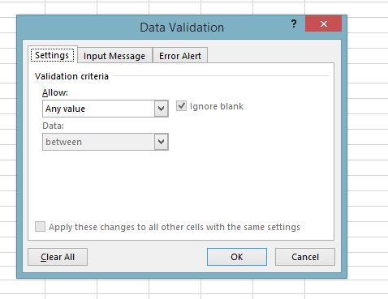
Settings Tab
The settings tab is where you enter the validation criteria. There are eight options available to validate for user input:
- Any Value - It removes any existing data validation.
- Whole Number - It allows only whole numbers. For example, you can specify that the user must enter the number between 0 to 30.
- Decimal - The user must enter a number with decimal values.
- List - The user will have to create a drop-down list to choose from.
- Date - The user will have to enter the date format.
- Time - The user should enter a time.
- Text Length - It validates input based on the length of the data.
- Custom - It validates the user input using a custom formula.
Input Message Tab
You can set the input message to explain what data is allowed in a given cell. This tab is optional.
- Check the 'show input message when the cell is selected'.
- Enter a title.
- Enter an Input message.

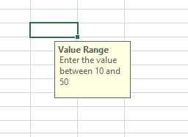
Error Alert Tab
You can show the error message if the user tries to enter the invalid data.
On the error message tab:
- Check the ‘Show error alert after invalid data is entered’ box.
- Enter a title.
- Enter an error message.

Now, when you try to enter the value beyond the range, you will get an error message.
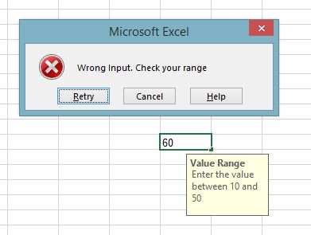
Now that we are familiar with the basic concepts, let’s look at a step-by-step process to implement data validation in excel.
How to Validate Data in Excel?
Step 1 - Select The Cell For Validation
Select the cell you want to validate. Go to the Data tab > Data tools, and click on the Data Validation button.
A data validation dialogue box will appear having 3 tabs - Settings, Input Message, and Error Alerts.
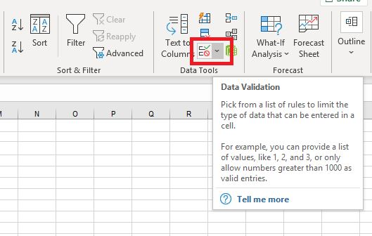

Step 2 - Specify Validation Criteria
On the settings tab, specify your validation criteria.
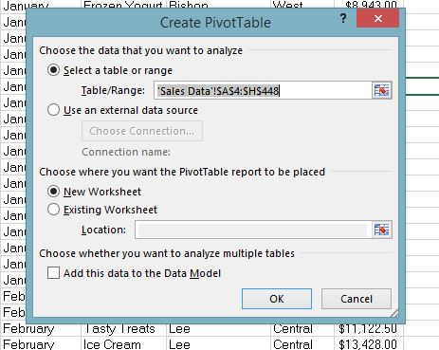

Step 3 - Under Allow, Select The Criteria
Under Allow, select an option from Whole Number, Decimal, List, Date, Time, Text Length, and Custom.


Step 4 - Select Condition
Under Data, select a condition and set required values based on what you choose for Allow and Data.


Step 5 - Input Message
You can enter the input message if you want. This step is optional.

Step 6 - Custom Error Message
You can also set your custom error message. This step is optional.

Step 7 - Click Ok
Click OK. Now, if you try entering a value outside the specified range (10, 50), it will result in an error
Excel Data Validation List (Drop-Down)
To add the drop-down list, follow the following steps:
- Open the data validation dialog box.
- On the Settings tab, select the list.
- In the source box, enter the list of your validation, separated by commas.
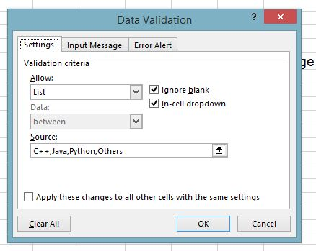
You will get the following result.
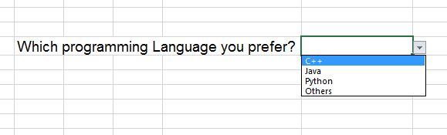
Date Validation
You can set-up the date validation in Excel. Select date in the allow box and pick up the appropriate criteria.
Follow these steps to set-up date validation:
- Select the cells where you’d be applying the data validation.
- From the allowed dropdown, select the date.
- From the Data drop-down, select between.
- Click in the Start Date box and select cell O10, where the Start Date is entered.
- Press the F4 key to change the cell reference to an absolute reference -- $O$10.
- Click in the End Date box and select cell O11, where the End Date is entered.
- Press the F4 key to change the cell reference to an absolute reference -- $O$11.
- Click OK to close the Data Validation window.
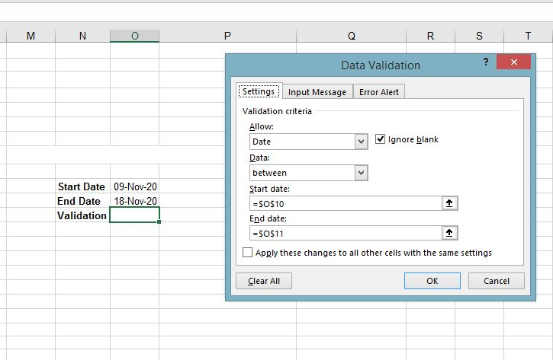
The above date validation will only accept date values between 9th Nov 2020 to 18th Nov 2020.

What is data cleaning?
Data cleaning is the process of fixing or removing incorrect, corrupted, incorrectly formatted, duplicate, or incomplete data within a dataset. When combining multiple data sources, there are many opportunities for data to be duplicated or mislabeled. If data is incorrect, outcomes and algorithms are unreliable, even though they may look correct. There is no one absolute way to prescribe the exact steps in the data cleaning process because the processes will vary from dataset to dataset. But it is crucial to establish a template for your data cleaning process so you know you are doing it the right way every time.
While the techniques used for data cleaning may vary according to the types of data your company stores, you can follow these basic steps to map out a framework for your organization.

Step 1: Remove duplicate or irrelevant observations
Remove unwanted observations from your dataset, including duplicate observations or irrelevant observations. Duplicate observations will happen most often during data collection. When you combine data sets from multiple places, scrape data, or receive data from clients or multiple departments, there are opportunities to create duplicate data. De-duplication is one of the largest areas to be considered in this process. Irrelevant observations are when you notice observations that do not fit into the specific problem you are trying to analyze.

Step 2: Fix structural errors
Structural errors are when you measure or transfer data and notice strange naming conventions, typos, or incorrect capitalization. These inconsistencies can cause mislabeled categories or classes. For example, you may find “N/A” and “Not Applicable” both appear, but they should be analyzed as the same category.

Step 3: Filter unwanted outliers
Often, there will be one-off observations where, at a glance, they do not appear to fit within the data you are analyzing. If you have a legitimate reason to remove an outlier, like improper data-entry, doing so will help the performance of the data you are working with. However, sometimes it is the appearance of an outlier that will prove a theory you are working on. Remember: just because an outlier exists, doesn’t mean it is incorrect. This step is needed to determine the validity of that number. If an outlier proves to be irrelevant for analysis or is a mistake, consider removing it.

Step 4: Handle missing data
You can’t ignore missing data because many algorithms will not accept missing values. There are a couple of ways to deal with missing data. Neither is optimal, but both can be considered.
- As a first option, you can drop observations that have missing values, but doing this will drop or lose information, so be mindful of this before you remove it.
- As a second option, you can input missing values based on other observations; again, there is an opportunity to lose integrity of the data because you may be operating from assumptions and not actual observations.
- As a third option, you might alter the way the data is used to effectively navigate null values.

Step 5: Validate and QA
At the end of the data cleaning process, you should be able to answer these questions as a part of basic validation:
- Does the data make sense?
- Does the data follow the appropriate rules for its field?
- Does it prove or disprove your working theory, or bring any insight to light?
- Can you find trends in the data to help you form your next theory?
- If not, is that because of a data quality issue?
False conclusions because of incorrect or “dirty” data can inform poor business strategy and decision-making. False conclusions can lead to an embarrassing moment in a reporting meeting when you realize your data doesn’t stand up to scrutiny.

Formatting text: or numbers can make them appear more visible especially when you have a large worksheet. Changing default formats includes things like changing the font color, style, size, text alignment in a cell, or apply formatting effects. This article shows you how you can apply different formats and also undo them.
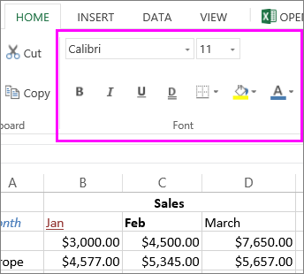
If you want text or numbers in a cell to appear bold, italic, or have a single or double underline, select the cell and on the Home tab, pick the format you want:
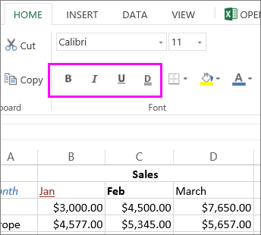
Windows Web:

Change font style, size, color, or apply effects
Click Home and:
- For a different font style, click the arrow next to the default font Calibri and pick the style you want.
- To increase or decrease the font size, click the arrow next to the default size 11 and pick another text size.
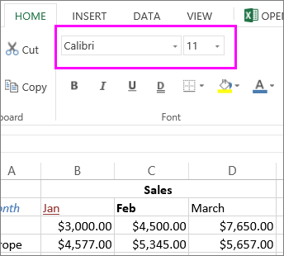
- To change the font color, click Font Color and pick a color.
- To add a background color, click Fill Color next to Font Color.
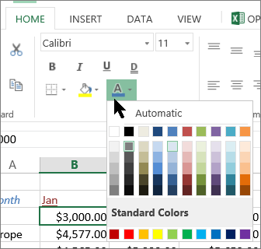
- To apply strikethrough, superscript, or subscript formatting, click the Dialog Box Launcher, and select an option under Effects.
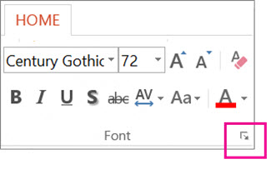 | 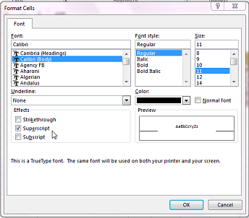

Change the text alignment
You can position the text within a cell so that it is centered, aligned left or right. If it’s a long line of text, you can apply Wrap Text so that all the text is visible.
Select the text that you want to align, and on the Home tab, pick the alignment option you want.
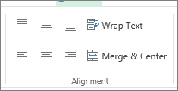
Clear formatting
If you change your mind after applying any formatting, to undo it, select the text, and on the Home tab, click Clear > Clear Formats.
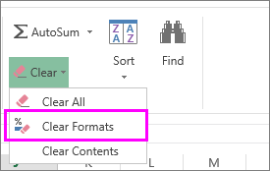

UNIT-4 & 5

What is Google Data Studio?
Google Data Studio is a web-based data visualization tool that helps users build customized dashboards and easy-to-understand reports. It helps in tracking key KPI's for customers, visualizing trends, and comparing performances over time.
What Are the Benefits of Using Google Data Studio?
- Easier set up with simple reporting.
- Creates customized and engaging reports.
- Pulls multiple data sources into a single report.
- Makes sharing and collaboration simple.
- Creates up to five customized reports that are free of cost.
- Helps the user connect to 150+ data sources.
- Monitors campaigns effectively.
- Reduces turnaround time on reporting.
How Do I Use Google Data Studio?

1. Log In
Go to Data Studio by visiting https://www.google.com/analytics/data-studio, and log in using your Google Analytics, Google Ads, or Search Console login information.
Now, you'll be taken to the Google Data Studio overview page. To view the dashboard, click the "Home" tab.

2. Explore the Data Studio Dashboard
The image below gives you an idea of how sample reports look, and the type of information you can fetch from your custom reports.
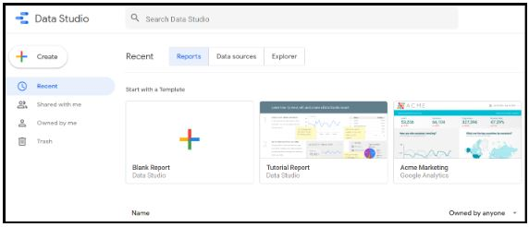
Data studio dashboard
The following image of "Welcome to Data Studio!" provides an interactive tutorial that will help you understand how to get started with Data Studio. Be sure not to miss out on this.
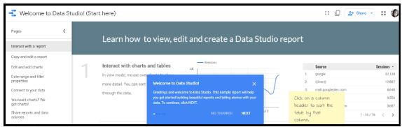
Welcome Page

3. Reports and Data Sources
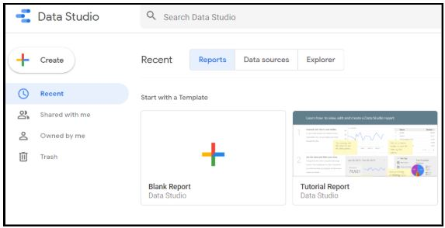
Reports and data sources - Data Studio
As shown in the above image, reports, and data sources are displayed on the dashboard of Data Studio. Reports let you create data visualizations. Data sources are the instance of a connector, that links your report to your external data, such as Google Analytics, Google AdWords, etc.

4. Connect Your First Source
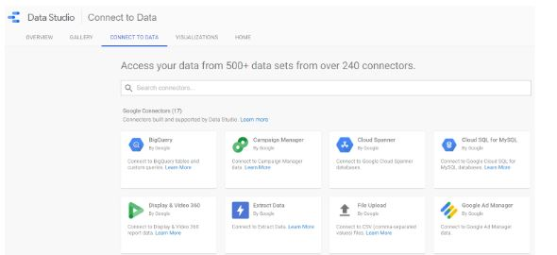
Connect Source - Data Studio
- Data sources act as a link to connect a Data Studio report to a collection of underlying data.
- Each data source has unique features and pre-built connectors that help users access and connect efficiently with the Data Studio.
- Data Studio supports 500+ data sources; some of the most popular sources are:
  - Google Analytics
  - Google Ads
  - Google Search Console
  - BigQuery
  - YouTube Analytics
  - PostgreSQL
  - Search Ads 360

How to Create a Report on Google Data Studio?
To create a new report, click on the blue plus (+) button at the bottom right-hand corner of the screen.
The two basic parts of any data report are:
- Data sources
- Widgets
Now, let’s set up a data source first and then build a widget.

Step 1: Add a Data Source
Data sources can be added using a data connector. Create a new blank report and add a data source (for example, Google Analytics) in the panel.
In this example, we will add a Google Analytics data source.
- First, add a ‘New Data Source’ button in the panel and select Google Analytics.
- Then, create a ‘New Report’ in the panel.
- Now, select a Connector for creating a new data source, and create a ‘New Data Source’ in the panel and add that to your report.
- Now, click the ‘Authorize’ option to authorize the connection between Data Studio and Google Analytics
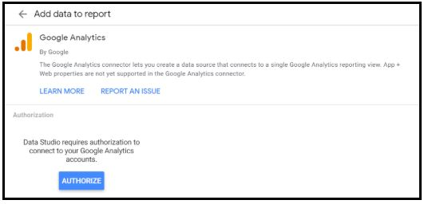
Authorization to Connect - Data Studio
Once it's authorized, go to the “Google Analytics Account” -> “Property” -> (the view you want to get data from) -> “Connect” (on the right corner of the page).
- As a result, the data source is now connected to your Google Studio. Now, a full list of metrics and dimensions are displayed in the new data source. If you want to add these metrics and dimensions to your report, click the ‘Add to Report’ button on the page.
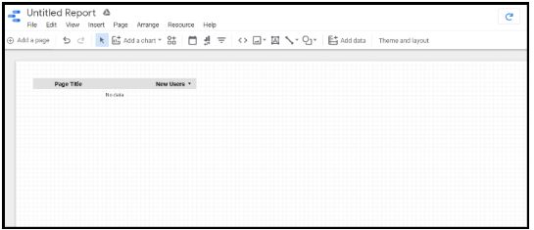
Add Dimensions and Metrics

Step 2: Add a Widget
Now, let's focus on creating visualizations that can be added to your report. Some of the visualization include:
- Pie Charts
- Bar Charts
- Time Series Graphs
- Tables
- Maps
- Scorecards
Additionally, you can also include design elements like text boxes that will make you understand your reports in an easier manner.
Some of the other important controller elements in the widgets are Date Selector (changes the date range of the data), Filter Controller (allows to modify the entire data in the report), and Data Control (an easier way to share reports with peers who are willing to use that report with their data).
Consider this example where you will create a simple time-series graph that shows the number of sessions that Google Analytics recorded.
- In the toolbar, select the “Insert” -> “Time Series” option.
- With the cursor, draw a graph on the report.
- As a result, the graph will be added to your report.
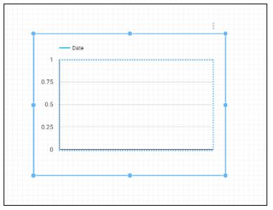
Time Series
By default, the graph will have ‘Session’ as the metric, and ‘Date’ as the dimension.

Step 3: Customize the Widget
The metric and dimension can be modified the way you want.
For example, you can add a comparison period, which allows you to compare your present data to the previous one. In the Date Range section, select ‘Auto’ and click on the dropdown menu below it and choose the ‘Start Date’ and ‘End Date’.
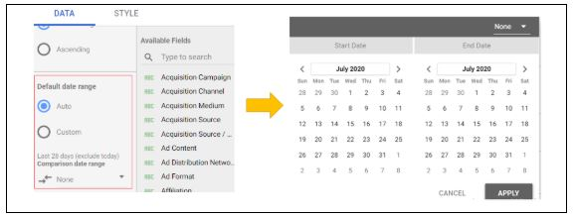
Dates

Step 4. Create Your Report Theme
Whether your report is for clients, teams, or managers, it'll be effective only if presented in the right way. To create your report style and formatting, click the ‘Theme and layout’ option in the toolbar.
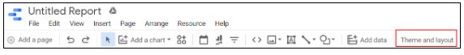
Theme and layout
Any changes made here will reflect upon your report.
This tool has many in-built themes such as simple, simple dark, constellation, groovy, etc. But, here it's simpler to design your style.
Some of the brightly colored themes available are displayed below:
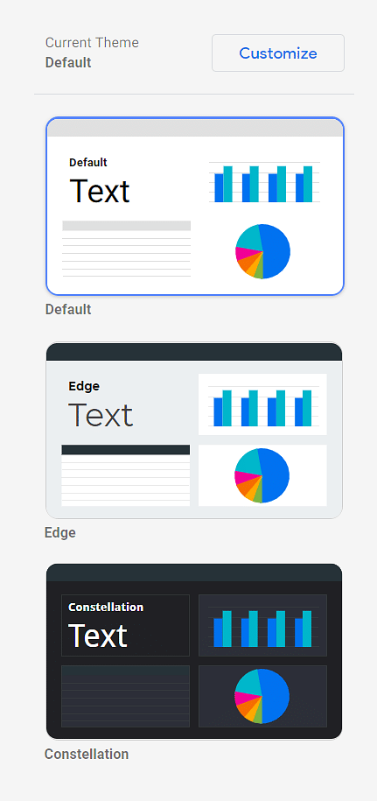
Current Theme
In the toolbar, go to “Theme and layout” -> “Theme” -> “Customize”
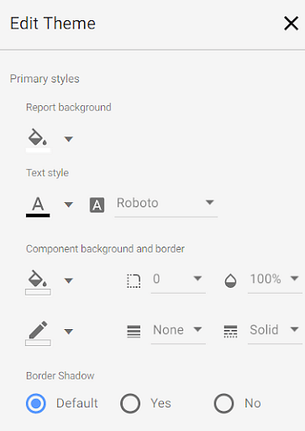
Edit Theme
Here, you can choose primary and secondary colors (from the color palette), fonts, and the text of your choice. This tab also lets you create a custom chart palette with more options for background settings.

Become a Data Scientist with Hands-on Training!
Data Scientist Master’s ProgramEXPLORE PROGRAM


Step 5: Embed External Content in Reports
With this feature, you can embed external files like Google Docs, Google Sheets, and even online videos to create the best experience for your clients.
- To add content, click “Insert” -> “URL embed”
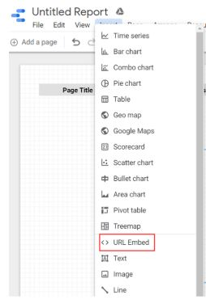
URL embed
- Now, a transparent frame appears on the screen. Resize and place the frame as required.
- On the properties panel, go to the ‘Data’ tab, enter the desired URL in the external content URL field.
- Now, configure the chosen content's frame border properties in the ‘Style’ tab.

Step 6: Share the Report
Here, you can share or invite others to view or access reports and data sources. Also, by turning on link sharing, anyone in your organization can view your Data Studio assets, despite not having a Google account. So, you just have to select the ‘Share’ button to let your customers or peers view or edit the reports.
Conclusion: This brings us to the conclusion of the ‘Google Data Studio’ article. Here, we learned what Google Data Studio is, what are the benefits of using Data Studio, and how to use Data Studio.
Google Data Studio is used by every digital marketer to conduct data analysis. Even a marketer who wants to understand Data Studio in-depth can enroll in our Advanced Digital Marketing course that will help in mastering Google Data Studio techniques and strategies.

Further reference to looker studio follow the below link
https://blog.coupler.io/google-data-studio-tutorial-for-beginners/
Navigating through multiple pages:Follow the beloww link
https://www.datastudio.ca/design-and-formatting/advanced-page-and-report-navigation-in-google-data-studio/

